Inclusion Protection Program Capacity Building Training Summary Report
By: Haley Sanner
Introduction:
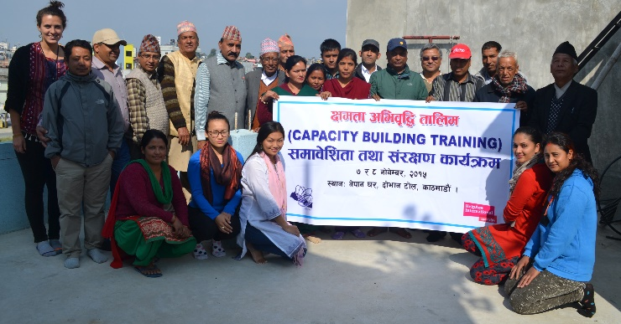
On 7th-8th November 2015, Nepal Participatory Action Network (NEPAN) conducted a Capacity Building Training under the sponsorship of HelpAge International Nepal’s (HAIN) Inclusion Protection Program (IPP). The 2-day training occurred at NEPAN Ghar with the goal of training local stakeholders in how to support the specific needs of older people and people with disabilities during situations of humanitarian relief. The main objective of the training was to equip the stakeholders with the knowledge, skills and attitudes to participate in developing a more inclusive society specifically in the wake of disaster.
The training was jointly facilitated by Gobinda Poudal, Fatik Thapa, and NEPAN program staff with guest facilitators Balkrishna Gaire, Chet Nath Kanel, and Shaligram Rijal. There were a total of 34 participants in the training.
In developing the material and interactive workshops, the facilitation team was challenged to appeal to a diverse group of participants ranging in age, occupation, location, ability and experience. Participants included older people, people with disabilities, VDC secretaries, CBO volunteers, DRC representatives, social workers and NGOs/INGOs representatives from various wards of Thankot, Dharmasthali, Goldhunga and Macchegaun. Additionally, 52 year age range (22-74) created a truly intergenerational training. We determined that the needs of our target audience were two-fold. For older participants and participants with disabilities, our goal was to empower them with the knowledge of their rights and help determine strategies for them to participate in the disaster relief development. For the community and government participants, our goal was to sensitize them to the specific needs and barriers of older persons and people with disabilities while providing them the tools to better support these vulnerable populations in the future. As NEPAN is a network founded on the ideals of participatory development, it seemed only fitting to use these principles as a means of transcending the diversity within our participant pool.
The training used a variety of interactive activities intermixed with informative presentations to engage participants in learning and employing their new knowledge to actively determine ways they can make change within their local communities.
Participants were provided snacks, lunch and transport reimbursement. Despite the blockade and shortage of petrol, thirty-four participants (along with NEPAN staff) were still able to attend the training and the time and effort they made to attend was not taken for granted. Unfortunately, the transportation challenge caused the training to start slightly behind schedule which would be improved upon in the future.
Training Day 1:
Training’s Major Contents:
HAIN’s IP Program Overview – Shova Rijal
Concept Activity – Gobinda Poudal
Rights for People with Disabilities - Balkrishna Gaire
Rights for Older Persons – Fatik Thapa
Participatory Tools Activity – Gobinda Poudal

After welcoming the participants, Shova Rijal (NEPAN’s IPP project coordinator) delivered on overview of the training including an explanation of the HAIN’s IP program.
Gobinda Poudal, NEPAN Executive Member, facilitated the first workshop that helped to level the diversity of experience and previous knowledge between participants and provide an opportunity for introduction. The goal of the workshop was to develop a unified understanding of key concepts relevant older people and people with disabilities in disaster relief. Knowledge of these concepts laid the foundation for more productive and inclusive discussions later in the training.
GUIDE TO PARTICIPATORY FACILITATION – CONCEPT ACTIVITY:
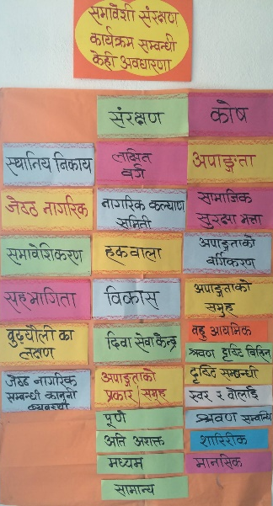
- Meta-cards with a single concept was distributed to each participant.
- Participants were asked to discuss their concept with their neighbor over chiyaa.
- Each participant presented themselves (name, location, occupation) and their concept to the group.
- Facilitator Gobinda Poudal closed by reinforcing these concepts through a brief power-point presentation.
Another facilitator, Balkrishna Gaire then gave an informative presentation on the "rights of people with disabilities" which included legal rights in the new Constitution, explanation of disability identity cards, and UN’s international standards. Not only was his presentation informative but he was able to relate the material to his own experiences which other participants found inspiring and motivating.
Over lunch, participants were able to reflect, meet new people and discuss lingering ideas. After, Fatik Thapa gave a power-point presentation covering development approaches, international rights for older persons and older persons’ status and inclusion in Nepalese society. He included information on the 2002 Madrid International Plan of Action on Ageing and the UN Convention of the Rights of Older Persons. The UN’s five principles “Independence, Participation, Care, Self-fulfillment, and Dignity” were posted on the wall to inspire and remind participants throughout the rest of the training.
Accordingly, Gobinda Poudal led the last activity provided participants the opportunity to use their new knowledge to determine the tools needed to ensure the rights of older persons and persons with disabilities rights upheld. The activity was very inclusive and participants were moving around and sharing experiences and opinions. He also included a poster on Participatory Rural Appraisal (PRA), which was not officially presented due to time constraints. PRA is an important participatory tool that could be used to ensure inclusive protection but the theory is more complicated and would be included in a longer training.
GUIDE TO PARTICIPATORY FACILITATION – TOOLS ACTIVITY:
- Participants were asked to write on separate meta-cards rights and supports they expected for older persons and people with disabilities during disaster phases (immediate, short-term and long-term).
- Then Gobinda Poudal distributed cards with other examples of supports and participants were instructed to consult with their neighbors.
- Participants were divided in small groups and tasked with categorizing the rights and supports by disaster phase (0-24 hrs, 24hrs-2 days, 2 days-7 months).
- Group members pasted their cards on the corresponding disaster phase chart and labelled party responsible for this support.
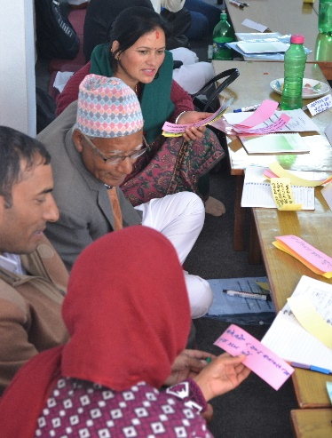
- A representative from each group was asked to present their group cards and explain why they categorized them in the corresponding disaster phase.
Training Day 2:
Training’s Major Contents:
Stoplight Debrief Activity – Gobinda Poudal
Monitoring & Tools – Gobinda Poudal
Development Networking – Chet Nath Kanel
Social Network Activity – Chet Nath Kanel
Social Allowances – Shaligram Rijal

The second day of the training opened with a debrief activity of the first day’s concepts. Key facilitator, Gobinda Poudal used a stoplight to determine participants’ level of understanding of concepts – green for topics understood thoroughly, yellow for topics that needed more clarity and red for topics not understood/not included/areas for improvement.
GUIDE TO PARTICIPATORY FACILITATION – STOPLIGHT ACTIVITY:
- Stoplight sign was used to visually represent to concept of the activity.
- Participants divided in small groups and were asked to write the responses on color coded post-it notes that corresponded with their level of understanding.
- All notes were posted on the stoplight poster for the entire group to read.
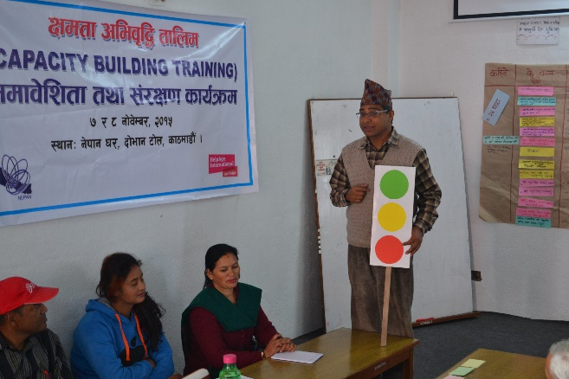
- A representative from each group presented their groups thoughts to the rest of group.

Then he led a session on "how to use tools to monitor support for older persons and people with disabilities". He created a chart and discuss how participants to check off monitoring tasks necessary for inclusion to help ensure accountability across important stakeholders. He, then, in line with NEPAN’s ideals of participatory development, encouraged participants to become leaders of inclusion within their own community to localize these monitoring meetings. If needed, NEPAN is available to help support participants in their local capacity building efforts.
Next, guest facilitator, Chet Nath Kanel, led a presentation on "development networking" that included an interactive activity and power-point presentation. The activity visually represented how social networking transcends physical location and connects people worldwide. The presentation discussed the different types of networking ranging from informal to formal and professional to social, internet security and how to join professional networks like NEPAN. Much of the information was new and informative especially for the older generation and emerging development professionals.
GUIDE TO PARTICIPATORY FACILITATION – SOCIAL NETWORK ACTIVITY:
- Participants were divided into groups based on location and arranged in a circle.
- A ball of string was pasted between participants who used Facebook, a medium for social networking.
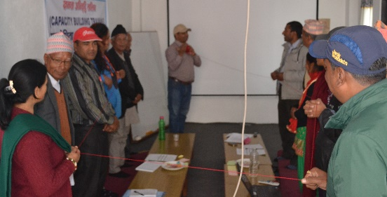
- Each person explained how long, how much, how many friends and why they use Facebook.

The last session was led by guest facilitator, Shaligram Rijal, a representative from the Ministry of Federal Affairs and Local Development (MOFALD). He explained the nuances of Nepal’s social allowance program by informing participants about eligibility and how to receive funds they or others in their community deserve. Further, he discussed the need for better data collection and public awareness in local communities about this government program and how participants can act as informants within their community. Participants discussed the need for a senior citizen card that would be recognized by transportation and other public offices to receive discounts for seniors.
Conclusion:
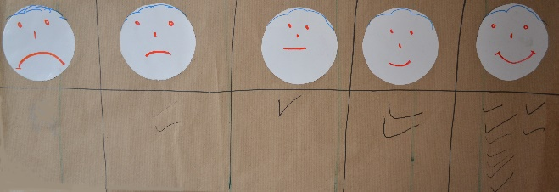
The program ended with a final debrief where people discussed their thoughts and opinions on the training. Overall, everyone was very positive about the new knowledge they gained and new relationships they built. Ten of the fifteen participants present at the end of the session expressed moderate or high satisfaction in regards to the training experience and no participants were highly dissatisfied.

Meeting the diversity of needs within the participant population was challenging and may have caused some dissatisfaction for more informed participants. But we believe that the diversity within the training provided fruitful discussion while creating empathy and new understanding across groups. One such fruitful outcome, was a strong commitment from participants to advocate to government offices for an Older Persons Identity Card to ensure that all people 60+ receive the discounts and services they are legally provided.
As a result of this training, representatives from Goldhunga along with NEPAN staff are currently working to implement this card within the Kathmandu Valley.
We found that it was important to make sure representatives and presenters from small group discussions were representative of gender, occupation and age during the training. This helped to promote inclusion within the training following the overall theme of our training. In the future, we would like to host a longer capacity building training as two days was too short to include all the material we would have liked to present. Based on the feedback by the participants, we hope to hold a five day training in the future. Additionally, we hope to expand the reach of this training beyond the Kathmandu Valley into other districts across Nepal at both the local and district levels.
If you are interested in receiving an electronic packet of the training information contact NEPAN at nepan@nepan.org.np. Also if interested, you can check out our new blog (www.NEPAN.weebly.com) to view our training video and for reflections from participants.

